QUERY PROCESSING FOR DATA SCIENCE

Experiment 1: Write a Pandas program to select distinct department id from employees file.

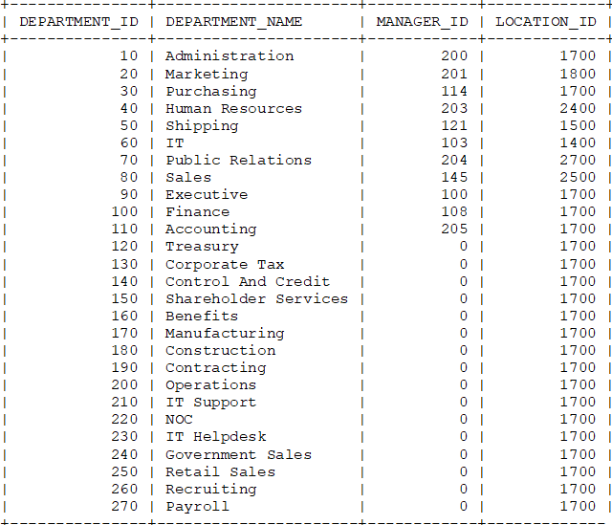

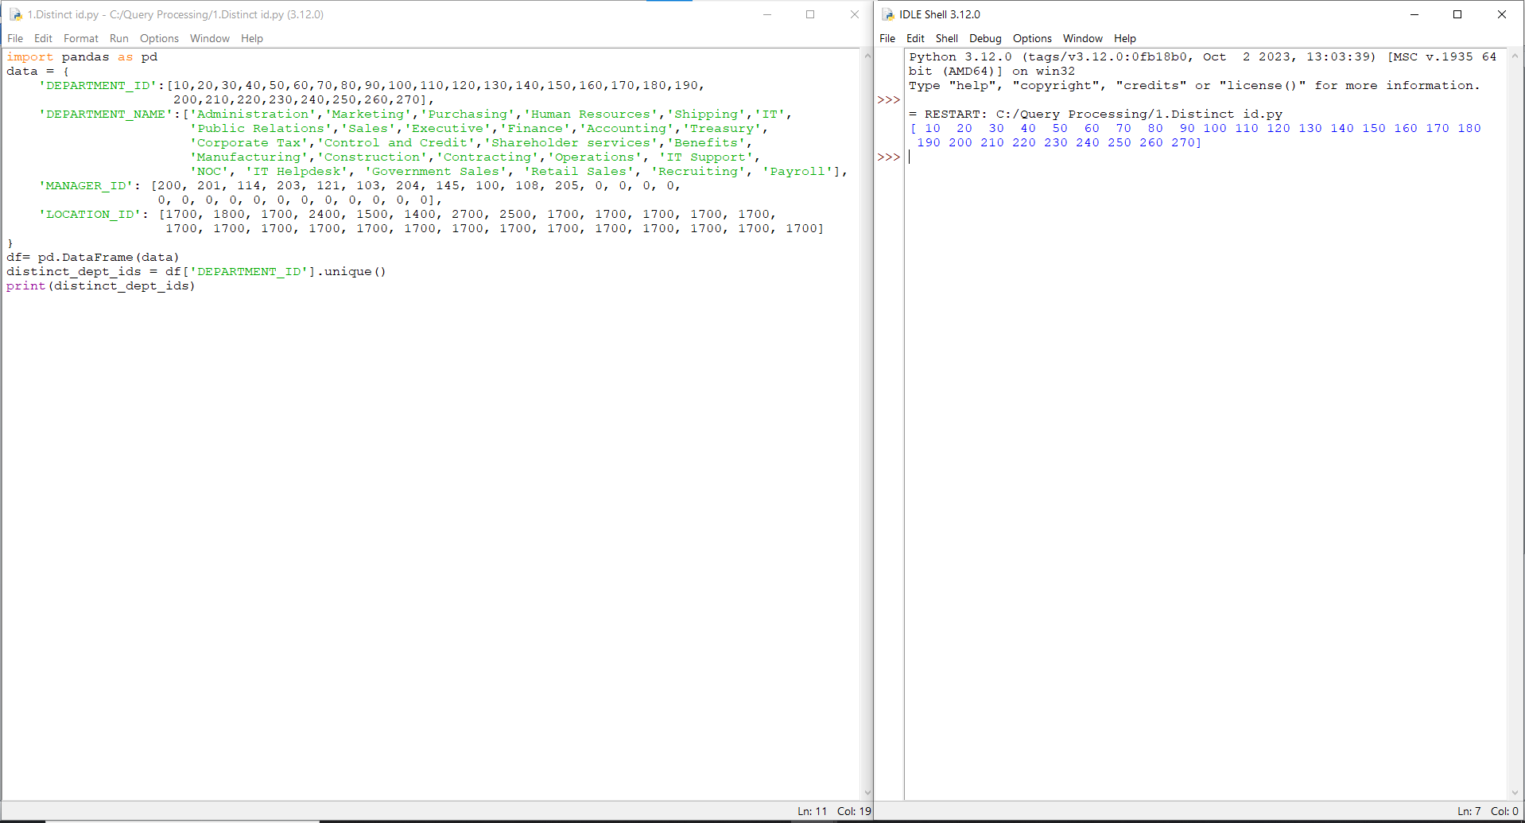

Experiment 2: Write a Pandas program to display the ID for those employees who did two or more jobs in the past.

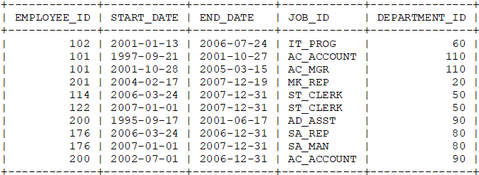

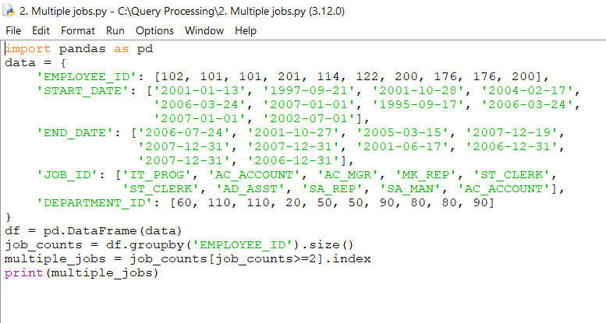

Output:

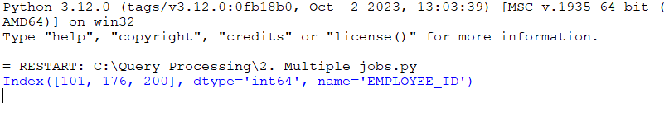Experiment 3: Write a Pandas program to display the details of jobs in descending sequence on job title.

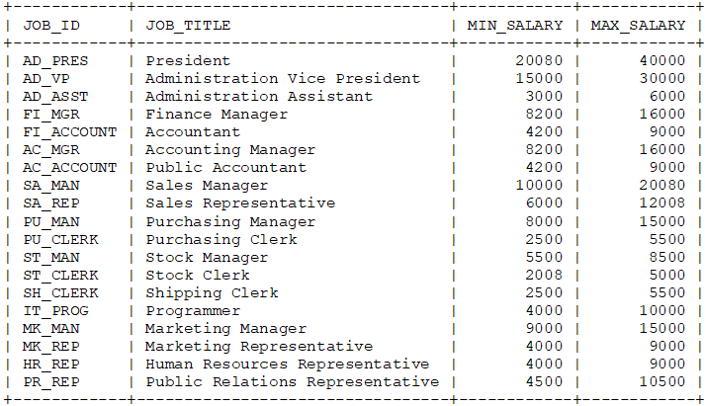

Program

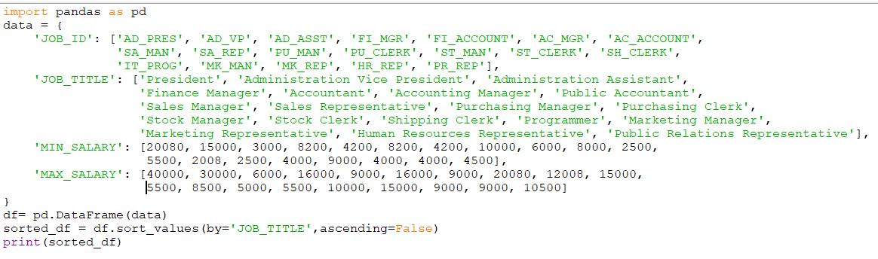

Output:

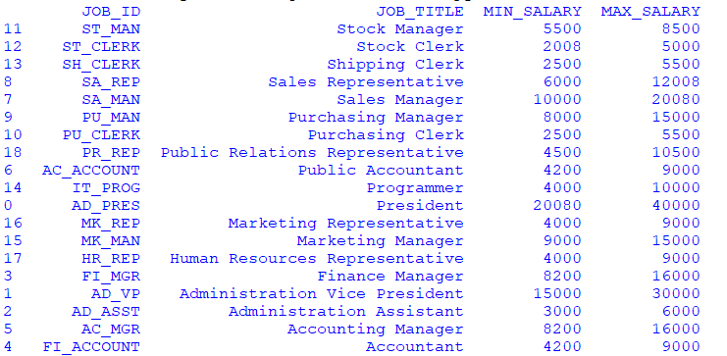

Experiment 4: Write a Pandas program to create a line plot of the historical stock prices of Alphabet Inc. between two specific dates.

Program:

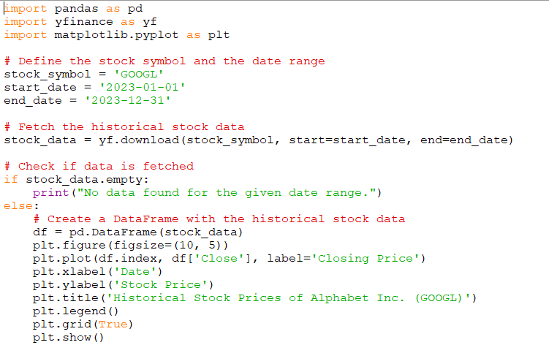

Output:

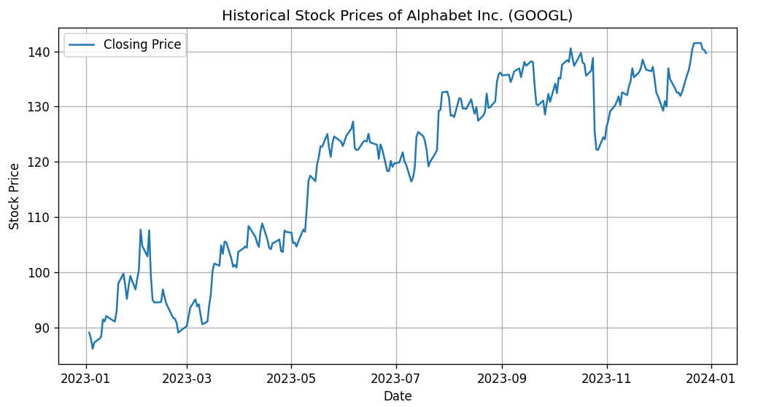

Experiment 5: Write a Pandas program to create a bar plot of the trading volume of Alphabet Inc. stock between two specific dates.

Program:

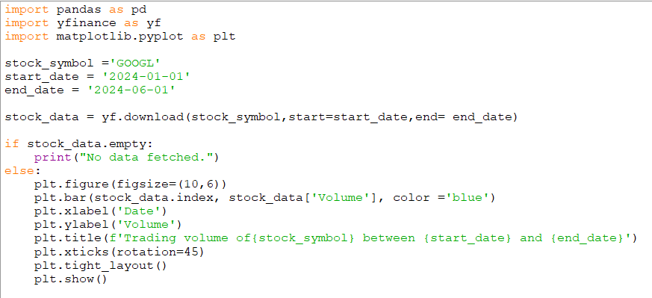

Output:

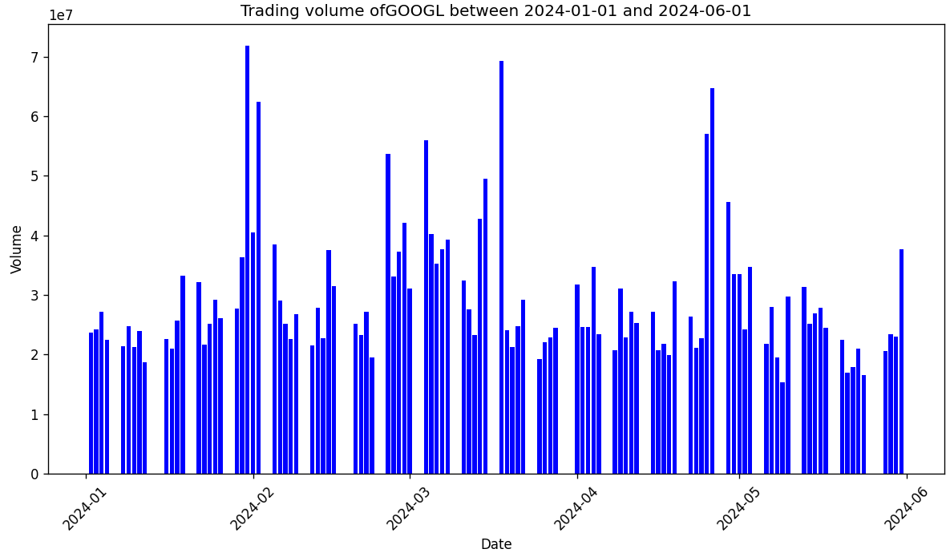

Experiment 6: Write a Pandas program to create a scatter plot of the trading volume/stock prices of Alphabet Inc. stock between two specific dates. **alphabet_stock_data:**

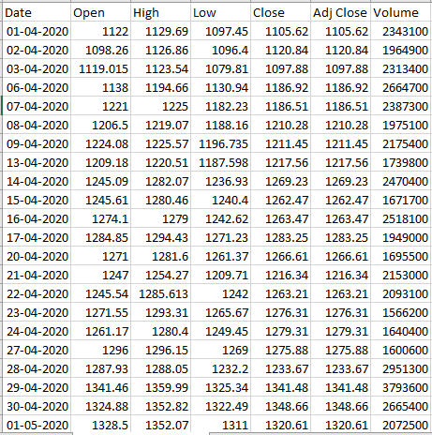

**Program:**

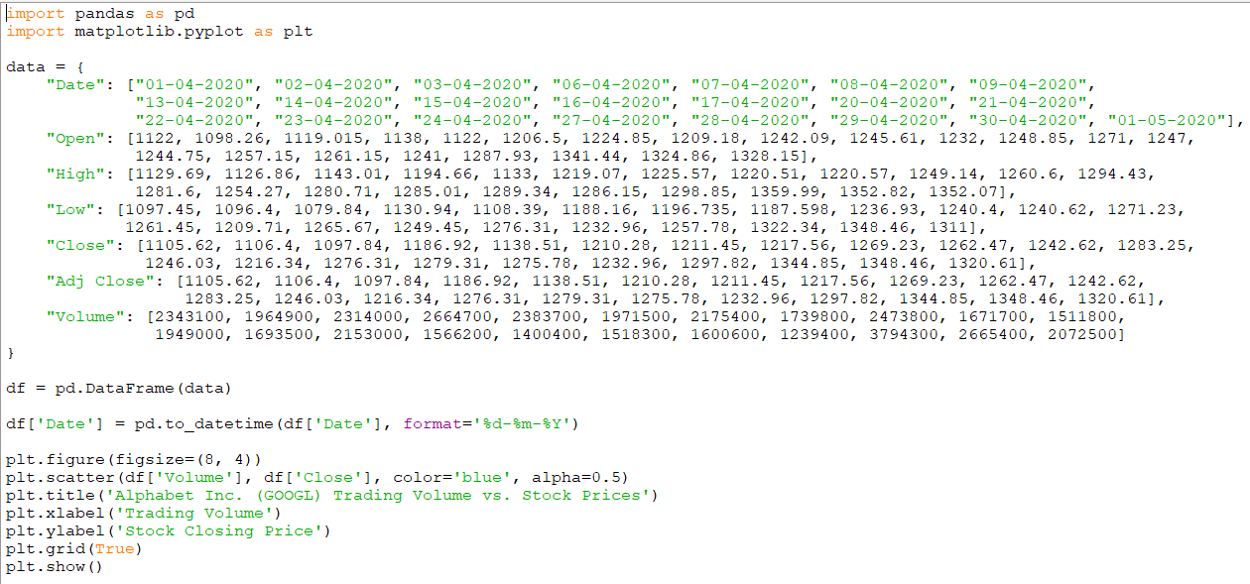

Output:

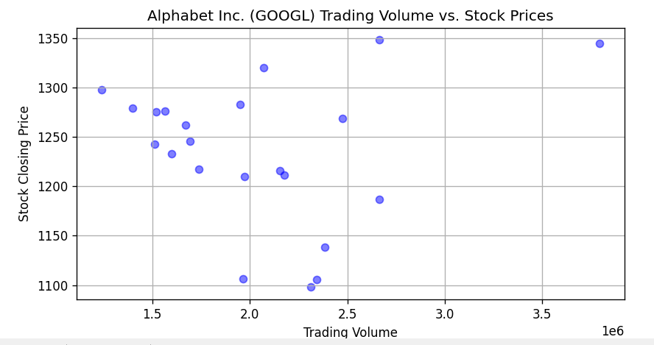

Experiment 7: Write a Pandas program to create a Pivot table and find the maximum and minimum sale value of the items.(refer sales_data table)

Program:

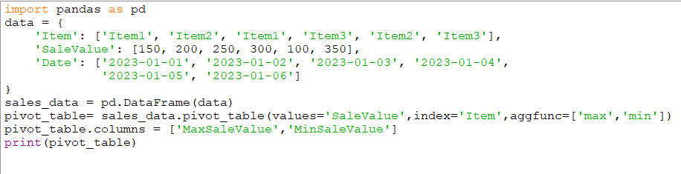

Output:

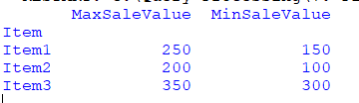

Experiment 8: Write a Pandas program to create a Pivot table and find the item wise unit sold. .(refer sales_data table)

Program:

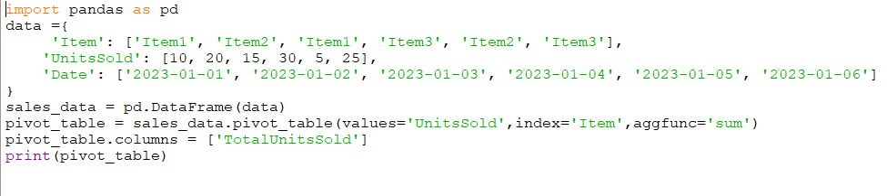

Output:

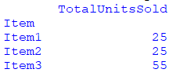

Experiment 9: Write a Pandas program to create a Pivot table and find the total sale amount region wise, manager wise, sales man wise. .(refer sales_data table)

**Sales_data:**

|  |  |  |  |  |  |  |  |
| --- | --- | --- | --- | --- | --- | --- | --- |
| **OrderDate** | **Region** | **Manager** | **SalesMan** | **Item** | **Units** | **Unit_price** | **Sale_amt** |
| 1-6-18 | East | Martha | Alexander | Television | 95 | 1,198.00 | 1,13,810.00 |
| 1-23-18 | Central | Hermann | Shelli | Home Theater | 50 | 500.00 | 25,000.00 |
| 2-9-18 | Central | Hermann | Luis | Television | 36 | 1,198.00 | 43,128.00 |
| 2-26-18 | Central | Timothy | David | Cell Phone | 27 | 225.00 | 6,075.00 |
| 3-15-18 | West | Timothy | Stephen | Television | 56 | 1,198.00 | 67,088.00 |
| 4-1-18 | East | Martha | Alexander | Home Theater | 60 | 500.00 | 30,000.00 |
| 4-18-18 | Central | Martha | Steven | Television | 75 | 1,198.00 | 89,850.00 |
| 5-5-18 | Central | Hermann | Luis | Television | 90 | 1,198.00 | 1,07,820.00 |
| 5-22-18 | West | Douglas | Michael | Television | 32 | 1,198.00 | 38,336.00 |
| 6-8-18 | East | Martha | Alexander | Home Theater | 60 | 500.00 | 30,000.00 |
| 6-25-18 | Central | Hermann | Sigal | Television | 90 | 1,198.00 | 1,07,820.00 |
| 7-12-18 | East | Martha | Diana | Home Theater | 29 | 500.00 | 14,500.00 |
| 7-29-18 | East | Douglas | Karen | Home Theater | 81 | 500.00 | 40,500.00 |
| 8-15-18 | East | Martha | Alexander | Television | 35 | 1,198.00 | 41,930.00 |
| 9-1-18 | Central | Douglas | John | Desk | 2 | 125.00 | 250.00 |
| 9-18-18 | East | Martha | Alexander | Video Games | 16 | 58.50 | 936.00 |
| 10-5-18 | Central | Hermann | Sigal | Home Theater | 28 | 500.00 | 14,000.00 |
| 10-22-18 | East | Martha | Alexander | Cell Phone | 64 | 225.00 | 14,400.00 |

Program:

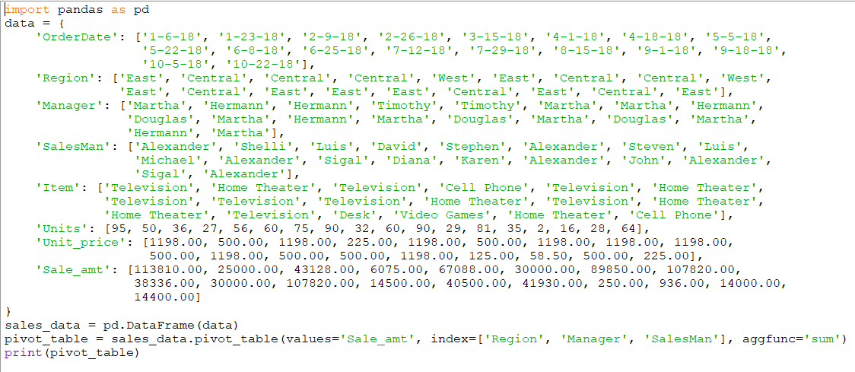

Output:

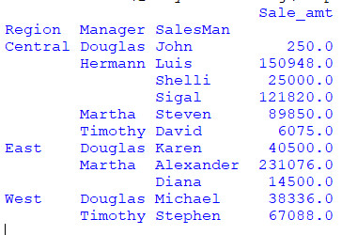

Experiment 10: Create a dataframe of ten rows, four columns with random values. Write a Pandas program to highlight the negative numbers red and positive numbers black.

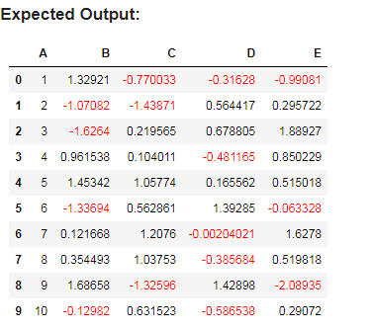

Program:

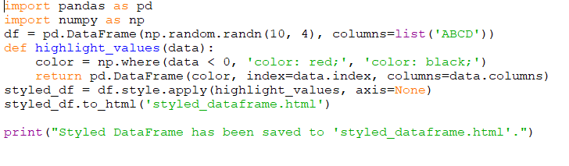

Output:

